Newsletter March 2014
Volume 31 Issue 3

President’s Message
Inside This Issue
1 President’s Message
2 This Month’s Project
Officers
Area Chapters Newsletter Editors
3 Meeting Minutes
4 Information from Other Chapters
5 Bluegrass Tolers’ 2014 Application
Jesus said to her, "I am the resurrection and the life. He who believes in me will live,
even though he dies; and whoever lives and believes in me will never die.
John 11:25-26
Spring and warmer weather have finally arrived. Our beloved (or most of our) Wildcats went to the Final Four and made it to the final game. Too bad for the loss, but what a season!! Most importantly this month is Easter – I hope each of your enjoy some family time and worship services.
We would like to thank Gayle Liable for bringing Spring a little early for us in March with a watercolor of tulips and dandelions. They all turned out beautiful. Barbara Ryan will be teaching our class this month. Please see details later in the newsletter and/or on our website: www.bluegrasstolers.com. We would also like to say we hope Barbara’s husband is doing better after a trip to the hospital last month.
Please let me or Mina (minasplace@aol.com) know if you plan on attending Barbara’s class at least one week ahead of the class so Barbara can prepare her canvases. Class starts at 9:30 sharp so please arrive early to have your painting spot set up and ready to paint.
Lunch will be provided by Debbie McQueary, our Hospitality Chair. The cost is $10 of which $2.00 will go in our club fund.
At our lunch meeting, we discussed a “Social Painting Class” to be offered to the public. It was decided to host a class at Marsha’s church in Midway and also at Diane’s church in Elizabethtown. Dates will be provided at the meeting. Please be willing to help work these and offer any other suggestions you may have as possible money makers for the club.
We all look forward to serving your needs and ask everyone to participate with thoughts, ideas, and a helping hand throughout the year.
Looking forward to seeing everyone,
Marsha
marshalclark@yahoo.com
502-545-3950

By Marsha Clark
Bluegrass Tolers


Neary Rattanak – Quote meaning: Women are Precious Gems (Gems are a thing of permanent strength and value, and if it is soiled, it can be polished and made to shine even more brightly.)
(from All That Is Bitter & Sweet, Ashley Judd’s Memoir, page 80)

This Month’s Project
Area Chapters Newsletter Editors
- Greater Cincinnati
Pat Hull (web site http://www.gcdapainters.org )
- Lake Cumberland Amanda Thompson (web site https://sites.google.com/site/lakecumberlanddecorativeartist)
- Kentuckiana Sandra Sturgeon (web site http://www.wix.com/kdapainters/kentuckiana-decorative-artists)

Officers
President: Marsha Clark
1st Vice-president: Mina McLean
2nd Vice-president: Debbie McQueary
Secretary: Jo Carol Carter
Treasurer: Byrle Thomas

Don’t forget to pay your Bluegrass Tolers’ and SDP dues!
Barbara Ryan is with us this month!

Contact: Mina McLean at
minasplace@aol.com or Marsha
Clark at marshalclark@yahoo.com

Date: April 17
Medium: Acrylics
Size: 8 X 8 canvas
Instructor Provides: Picture, pattern, instructions, canvas
Cost: $25
Student Brings: Acrylic supplies.



Meeting Minutes submitted by Jo Carol Carter 
- The March 20, 2014 meeting of the Bluegrass Tolers was held at the Extension Building in Versailles, KY. The lesson was presented by Gayle Laible, CDA. The project was a watercolor Tulip and Dandelions design.
- Marsha Clark presided at the meeting an agenda is attached. The February 20, 2014, minutes were read and approved.
- Attending 10 members were: Marsha Clark, Connie Bolin, Mina McLean, Diane McCamish, Debbie McQueary, Jo Carol Carter, Carolyn Leet, Byrle Thomas, Sowmya Viji and Nina Parker.
- The luncheon was provided by Debbie McQueary.
- The financial report was submitted by Byrle Thomas. The 3/20/14 balance is $4014.04. A motion was made by Jo Carol Carter seconded by Connie Bolin to accept the report. The motion was approved.
- The 2014 club projects were discussed. Dorothy Dent will be coming to present to the club in 2015 – March is the tentative month. Mina McLean presented a list of projects:
  - Barbara Ryan – April
  - Mina McLean – May
  - Byrle Thomas – June
  - Debbie McQueary – July
  - The Club is implementing a standing policy that members will be signing in and paying for each month’s lesson in advance. If members cannot commit at the month meeting, they are to contact Mina directly at least one week in advance.
- Old Business:
  - Debbie McQueary catered the luncheon. Debbie presented a plan to begin catering for the club on a permanent basis. A motion was made by Mina McLean and seconded by Diane McCamish to accept Debbie’s plan for catering lunches. The lunches will be ten dollars and two dollars of this amount will go to the club. If it becomes necessary, due to raising food costs, Debbie was given approval to implement necessary cost adjustments without requiring additional club approval. It was duly noted that other SDP clubs in KY pay for lessons and lunches in advance. In order for Debbie to manage the amount of food necessary, it is not only a courtesy but a necessity that club members notify Mina in advance if they will be attending meeting and dining on club days. The motion was unanimously approved.
  - Social Painting updated: Marsha Clark is working on designated dates “Social Painting with Friends” to be held at her church. Diane McCamish will research the possibility of having a Social Painting at her church. Diane will let the club know her finding. Mina McLean is working with Deco Art on obtaining supply kits.
- Since there was no further business, a motion was made by Jo Carol Carter and seconded by Connie Bolin to adjourn the meeting.

Lake Cumberland Decorative Artists - Mark Polomchak will be doing a watercolor seminar on May 23 and 24, 2014, in Somerset, KY. Cost of $60.00 per day for members. Non-members will be invited if there are any openings after member sign up - cost of $60.00 per day plus $15.00 club membership dues. Sign up and deposits are collected by Treasurer, Barbara Ryan.

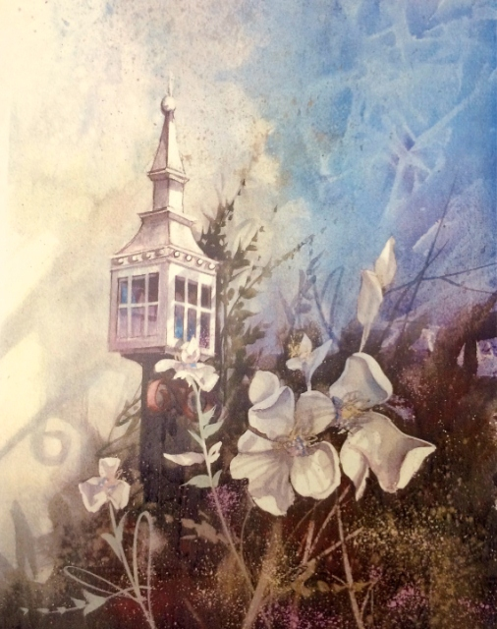

Kentucky Decorative Artists – Jude Creager will teach a “Tulip Zentangle” in May and Valerie Bernardino will be teaching a watercolor in June. Watch for upcoming information about both classes.

Hello from Texas, The Yellow Rose Chapter of Dallas, Texas is planning an Alaskan cruise for September 7th, 2014 and would like to extend an invitation to all other painting chapters.

CONTACT – RORY MORGAN, CRUISE COMMITTEE CHAIR, address: 20 A Rhea Mills Cr, Prosper, TX 75078 or email yrc2014akcruise@yahoo.com
PS – The Seattle Painting Convention starts on September 17th,2014 – what a great way to add on some painting and shopping time.

Information from Other Chapters
Bluegrass Tolers 2014 Membership Application

$15.00
Mail to:
Byrle Thomas
4591 Leitchfield Rd
Cecilia, KY 42724

Name: __________________________________________

Address: _______________________________________

City_________________State_________________Zip_____

Phone___________

E-mail___________________________

Permission to list in Directory ___Yes ____No

New_____ Renewal_____

Student____ Teacher_____

Shop Owner____

Name of Business_________________

Birthday (Day/Month) ___________________

Make checks payable to Bluegrass Tolers

Amount Enclosed: check __________________ cash____________

